SRET | Date: 31st March 2022

A Report on Inauguration of
IEEE Student Branch (STB60203906)
of Sree Rama Engineering College
Sree Rama Engineering College has celebrated the inauguration of IEEE student branch on 31st March 2022. On behalf of this occasion, we invited Dr. Rama Krishna Sai Gorthi, Associate Professor of Electrical Engineering, IIT Tirupati as chief guest for this function. Mr. T. Vidya Sagar, SAC Chair, IEEE Hyderabad section and Prof. Y.V. Siva Reddy, Chair, IEEE Ananthapuramu sub-section were attended this function virtually through Microsoft teams as Guests of Honor.
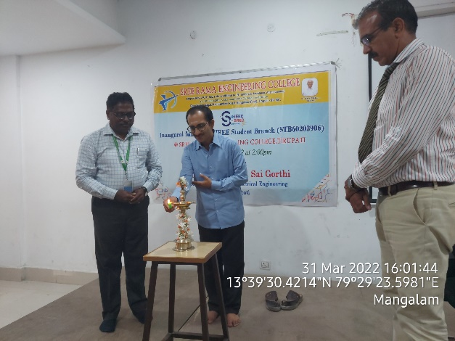
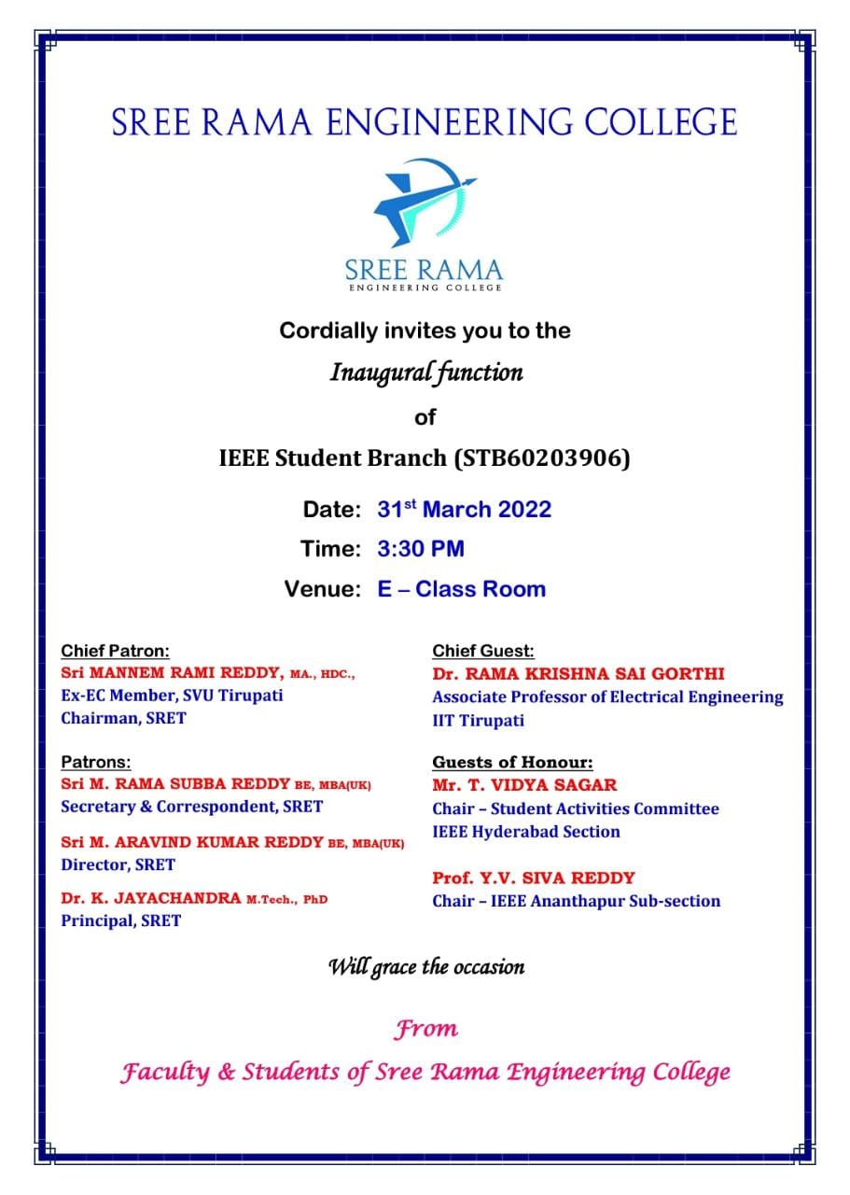

Lightning the Lamp by Chief Guest

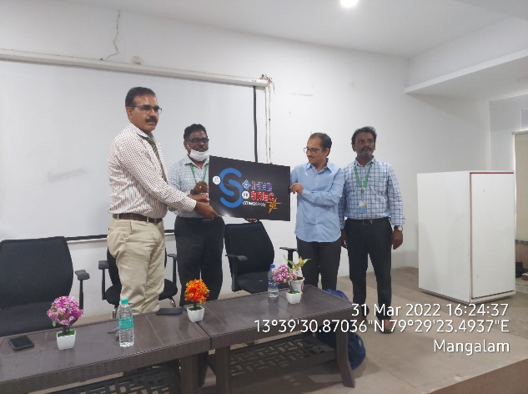

Inauguration of IEEE logo by Chief Guest
Invitation for Inauguration of SRET IEEE SB

The chief guest addressed the students and explained the benefits of IEEE membership for the students. He also advised the students to update their knowledge with new advancements in technology by following IEEE journals, conferences and magazines.
Ms. G. Renu, Joint section student representative, IEEE SAC Hyderabad section interacts with the students and shares her experiences as a member in IEEE. She also motivates the students in organizing events with active contributions.

At last, Dr. A. Muni Sankar, IEEE Student Branch Counselor of SRET had delivered vote of thanks to the SRET management, distinguished speaker from IIT Tirupati, Mr. T. Vidya Sagar, Chair for SAC, IEEE Hyderabad section and Prof. Y.V. Siva Reddy, Chair for IEEE Ananthapur Sub-section, IEEE student members. Later, the inauguration ends with National Anthem.

Dr. K. JAYACHANDRA
Principal, SRET
Dr. A. MUNI SANKAR
IEEE Student Branch Counselor, SRET

