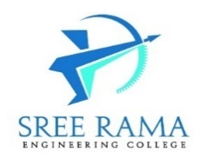
SREE RAMA ENGINEERING COLLEGE
(Approved by AICTE, New Delhi - Affiliated to JNTUA, Ananthapuramu)
An ISO 9001:2015 & ISO 14001:2015 certified Institution
Rami Reddy Nagar, Karakambadi road, Tirupati-517507

List of Faculty having CSI membership

Institute Membership No.: 5024220007
S.  No. | Name of the Faculty member | Designation | Email | Ph. No. | CSI Membership Id
1 | Dr.J.Naga Muneiah | Professor | nagamuni.sret@gmail.com | 9581026101 | 5023220037
2 | Mr G. Lakshmikanth | Associate Professor | hod.cse@sreerama.ac.in | 6300146556 | 5023220035
3 | Mrs G. Chandra kala | Assistant Professor | chandrakala.gopisetty@ gmail.com | 7207744499 | 5023220036

Principal

