CURRICULUM -VITAE

- Name : M Yagnesh
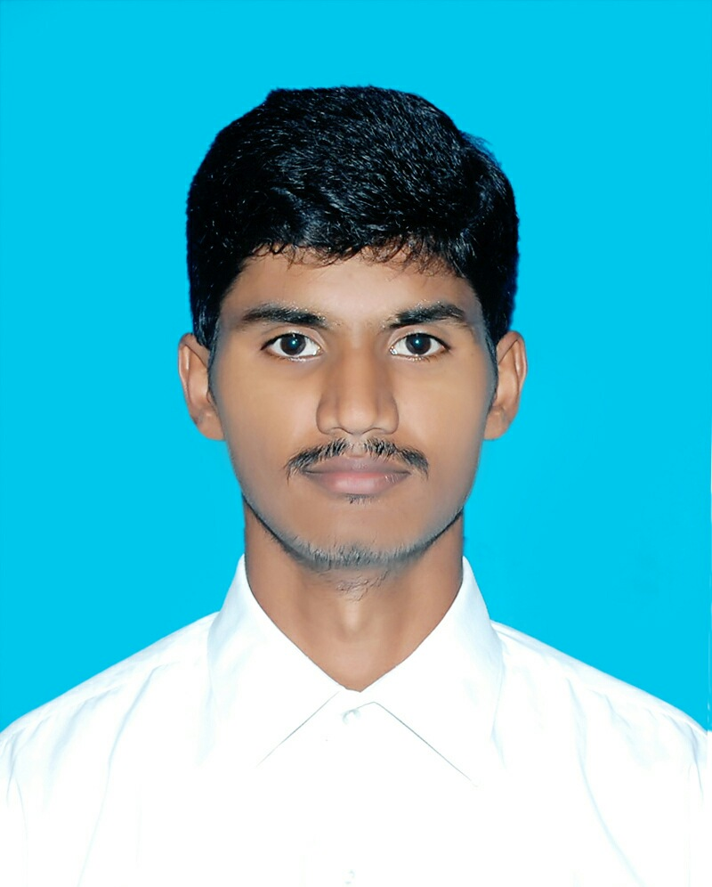
- Address for communication : 15/105, BP Agraharam, Srikalahasti
- Mobile Number : 8688128217

- Email : yagneshjnv9@gmail.com

- Date of Birth : 25/07/1996

- Academic Qualifications:

Degree | Year of Passing | Specialization | Institution/ University
M. B.A | 2020 | HR,FINANCE | JNTUA University
B. Com. | 2018 | General | SV University, Tirupati
Intermediate/ Diploma | 2015 | C.E.C | Board of Intermediate Education A.P
SSC | 2012 |  | Central Board of Secondary Education

- Total Experience : 11 MONTHS
- Details of Experience:

Organization | Position | From | To | No. of Years
SREE RAMA ENGINEERING COLLEGE | Asst. Professor | 22/04/2021 | TILL DATE | 11 months

- Ratification by the JNTUA, Anantapur : NO
- Area of research :
- Membership of Professional Bodies : IAAC Membership
- Administrative Experience :

- Computational Experience :

- MBA Courses taught:

S.no. | Name of the subject | No. of times taught
1. | GLOBAL HUMAN RESOURCE MANAGEMENT | 1
2. | HUMAN RESOURCE MANAGEMENT | 1
3. | FINANCIAL ACCOUNTING FOR MANAGERS | 1
4. | LABOUR LAWS AND LEGISLATIONS | 1
5. | RURAL MARKETING | 1

15. B. Tech Courses taught :

S.no. | Name of the subject | No. of times taught
1. | MANAGERIAL ACCOUNTING & FINANCIAL ANALYSIS | 1
2. | UNIVERSAL HUMAN VALUES | 2
3. | CONSTITUTION OF INDIA | 1

16. Research Interests:

17. Projects Guided : MBA Projects: NIL

18. Publications

International Journals: NIL

National and International conferences: NIL

- Books published: NIL

20. Patents: NIL

- FDP(s)/ Workshop(s)/ Training Course(s) attended:

1. FDP on “An Overview of the Indian Capital Markets and Indian Economy”
2. Workshop on “Communication Competencies for Online Reflective Teaching and Learning:
Global Perspective”
3. A Workshop on “NAAC Assessment and Accreditation - A Step by Step Process”
4. Participated in an online Advanced Excel Workshop on 06 June 2021

Signature of the Faculty

