CURRICULUM -VITAE

- Name : L. Usha Rani
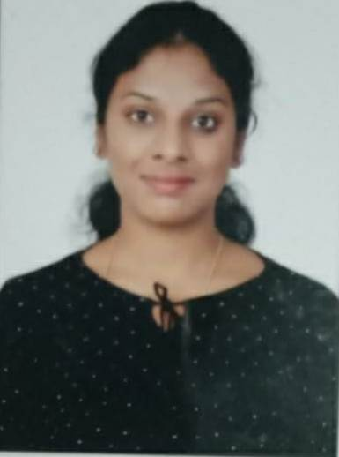
- Address for communication : 407,Lasya Aportments, Karkambadi
- Mobile Number : 9646273408

- Email : usharanilankipalli71@gmail.com

- Date of Birth : 27/12/1994

- Academic Qualifications:

Degree | Year of  Passing | Specialization | Institution / University
M. B.A | 2017 | HR, MARKETING | JNTUA
B.Com | 2015 | Accounts | SV University, Tirupati
Intermediate/ Diploma | 2012 | Bi.P.C | Board of Intermediate Education A.P
SSC | 2010 |  | Central Board of Secondary Education

- Total Experience : 2 years
- Details of Experience:

Organization | Position | From | To | No. of Years
SREE RAMA ENGINEERING COLLEGE | Asst. Professor | 05/10/2021 | TILL DATE | 7 months
KMMITS | Asst. Professor | 02/06/2018 | 02/06/2020 | 2 Years

- Ratification by the JNTUA, Anantapur : NO
- Area of research :
- Membership of Professional Bodies : IAAC Membership
- Administrative Experience :

- Computational Experience :

- MBA Courses taught:

S.no. | Name of the subject | No. of times taught
1. | Human resource management | 2
2. | Entrepreneurship Development | 2
3. | Service Marketing | 1
4. | Marketing management | 1

15. B. Tech Courses taught :

S.no. | Name of the subject | No. of times taught
1. | Entrepreneurship Development | 2
2. | Management Science | 2

16. Research Interests :
17. Projects Guided : MBA Projects: 10

18. Publications

International Journals

National and International conferences

- Books published:

19. Patents:

- FDP(s)/ Workshop(s)/ Training Course(s) attended:

  - UGC CARE Group 1

Signature of the Faculty

