CURRICULUM -VITAE

- Name : T Saritha
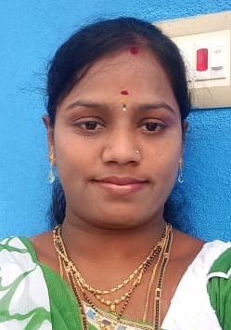
- Address for communication : 9/114 Y.R Pallem(V) Settipalli(P) Renigunta(M)
- Mobile Number : 7989617504

- Email : sarithasarayu79@gmail.com

- Date of Birth : 11/07/1990

- Academic Qualifications:

Degree | Year of Passing | Specialization | Institution/ University
Ph. D
M. B.A | 2012 | HR,FINANCE | S.V University
B. Com. | 2010 | ZBC | SV University, Tirupati
Intermediate/ Diploma | 2007 | BI.P.C | Board of Intermediate Education A.P
SSC | 2005 |  | Board of Secondary Education

- Total Experience : 7 Years 9 Months
- Details of Experience:

Organization | Position | From | To | No. of Years
SREE RAMA ENGINEERING COLLEGE | Asst. Professor | 22/04/2021 | TILL DATE | 4 Years 7 months
VEMU INSTITUTE OF TECHNOLOGIES | Asst. Professor | 10-05-2013 | 11-07-2016 | 3Years  2Months

- Ratification by the JNTUA, Anantapur : YES
- Area of research :
- Membership of Professional Bodies : IAAC MEMBERSHIP
- Administrative Experience :

- Computational Experience :

- MBA Courses taught :

S.no. | Name of the subject | No. of times taught
1. | GLOBAL HUMAN RESOURCE MANAGEMENT | 6
2. | HUMAN RESOURCE MANAGEMENT | 7
3. | PRODUCTION AND OPERATIONS MANAGEMENT | 5
4. | MANAGEMENT & ORGANIZATION BEHAVIOR | 7
5. | MANAGERIAL ECONOMICS | 4

15. B. Tech Courses taught :

S.no. | Name of the subject | No. of times taught
1. | MANAGERIAL ECONOMICS & FINANCIAL ANALYSIS | 6
2. | MANAGEMENT SCIENCE | 5
3. | PRODUCTION AND OPERATIONS MANAGEMENT | 3
4. | HUMAN VALUES AND PROFESSIONAL ETHICS | 2
5. | ENTREPRENEURSHIP & INCUBATION | 1
6. | RESEARCH METHODOLOGY | 1

16. Research Interests :
17. Projects Guided : MBA Projects: 60 MEMBERS

18. Publications

International Journals: NIL

National and International conferences: NIL

- Books published: NIL

19. Patents: NIL

- FDP(s)/ Workshop(s)/ Training Course(s) attended:

Signature of the Faculty

