CURRICULUM -VITAE

- Name : K Subhadra
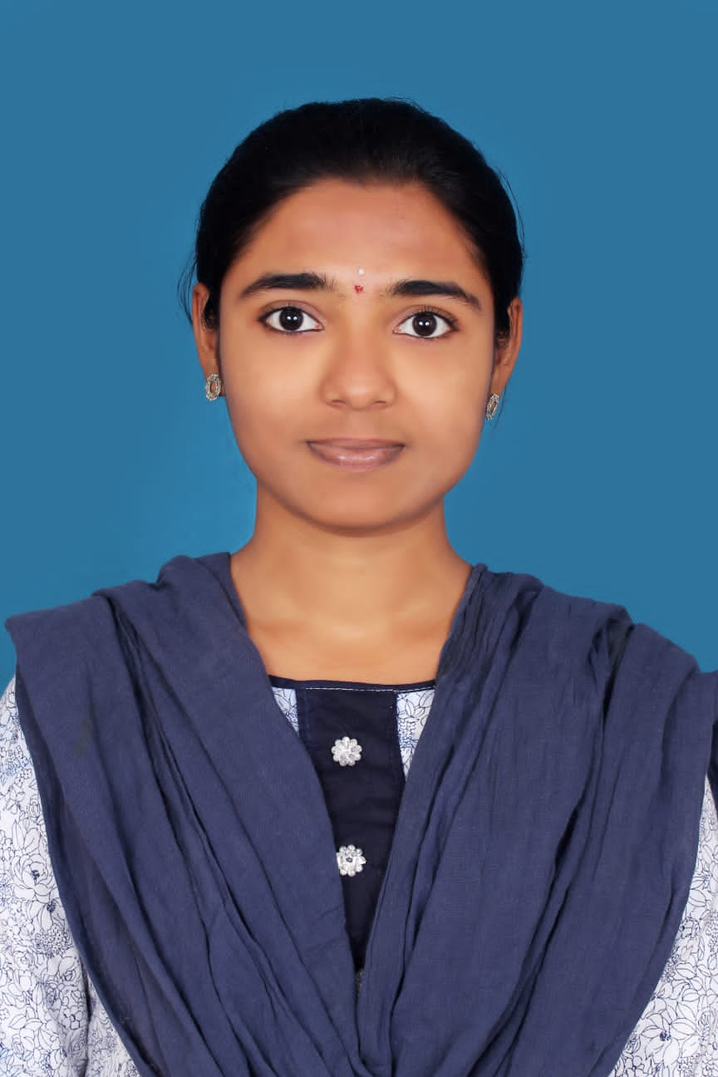
- Address for communication : 10-430, Kranthi Nagar, Jeeva Kona, Tirupati
- Mobile Number : 8686398149

- Email : subhasubhadra27@gmail.com

- Date of Birth : 27-04-1998
- Academic Qualifications:

Degree | Year of Passing | Specialization | Institution/ University
M. B.A | 2021 | HR,FINANCE | JNTUA University
B. Com. | 2019 | General | SV University, Tirupati
Intermediate/ Diploma | 2016 | C.E.C | Board of Intermediate Education A.P
SSC | 2013 |  | Central Board of Secondary Education

- Total Experience : 07 MONTHS
- Details of Experience:

Organization | Position | From | To | No. of Years
SREE RAMA ENGINEERING COLLEGE | Asst. Professor | 1/10/2021 | TILL DATE | 07 months

- Ratification by the JNTUA, Anantapur : NO
- Area of research :
- Membership of Professional Bodies :
- Administrative Experience :

- Computational Experience :

- MBA Courses taught:

S.no. | Name of the subject | No. of times taught
1. | Investment and Portfolio Management | 1

15. B. Tech Courses taught :

S.no. | Name of the subject | No. of times taught
2. | UNIVERSAL HUMAN VALUES | 1
3. | CONSTITUTION OF INDIA | 1

16. Research Interests:

17. Projects Guided : MBA Projects: NIL

18. Publications

International Journals: NIL

National and International conferences: NIL

- Books published: NIL

20. Patents: NIL

- FDP(s)/ Workshop(s)/ Training Course(s) attended:

Signature of the Faculty

